Question 5: (2 marks)
The given file Q5.cpp already contains the function named calCos with 2 parameters x and c but its body is empty. You should complete this function to perform the following task:
Return value of cos(x) using the approximate formula below:
cos x = 1 - 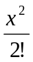 + 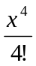 -... +(-1)^{n} 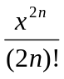
here n is the first integer for which | 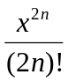| ≤ c is satisfied.

Notes:
- You can create new function(s) if you see it is necessary.
- Do not edit the main function.

Sample output:
